Course Registration and Timetable Scheduler
Version 1.2 approved
Prepared by: zohaib zafar
Date created: 17-sep-26
Table of Contents
7. System Sequence Diagrams (SSDs)
7.1 UC1: Login
7.2 UC2: Logout
7.3 UC3: Manage Courses
7.4 UC4: Register Courses
7.5 UC5: Drop Course
7.6 UC6: Generate Time Table
7.7 UC7: View Time Table
7.8 UC8: Generate Reports
8. Domain Model
9. Sequence Diagram
14. Reference

System Sequence Diagrams (SSDs)

UC1: Login

Figure 2: System Sequence Diagram for UC1

UC2: Logout

Figure 3: System Sequence Diagram for UC2

UC3: Manage Courses

Figure 4: System Sequence Diagram for UC3

UC4: Register Courses

Figure 5: System Sequence Diagram for UC4

UC5: Drop Course
Figure 6: System Sequence Diagram for UC5

UC6: Generate Time Table

Figure 7: System Sequence Diagram for UC6

UC7: View Time Table

Figure 8: System Sequence Diagram for UC7

UC8: Generate Reports

Figure 9: System Sequence Diagram for UC8

Domain Model

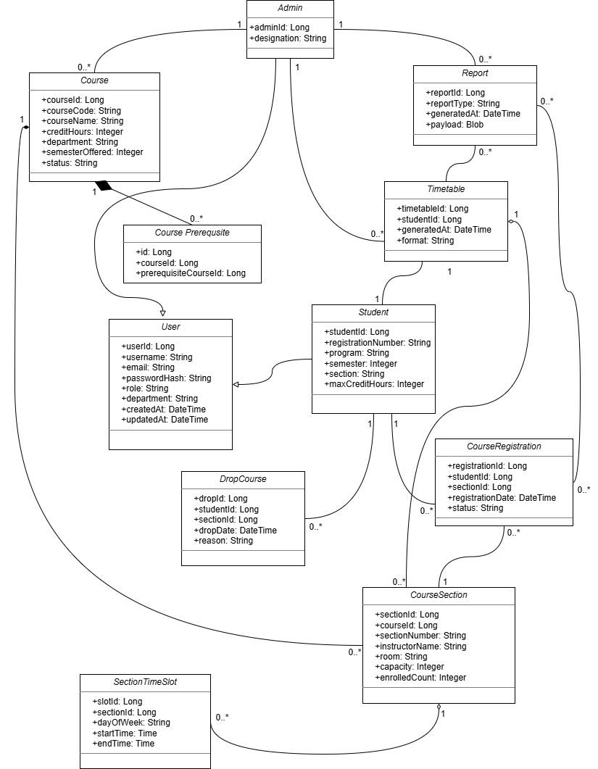
Figure 10: Domain Model for Course Registration and Timetable Scheduler

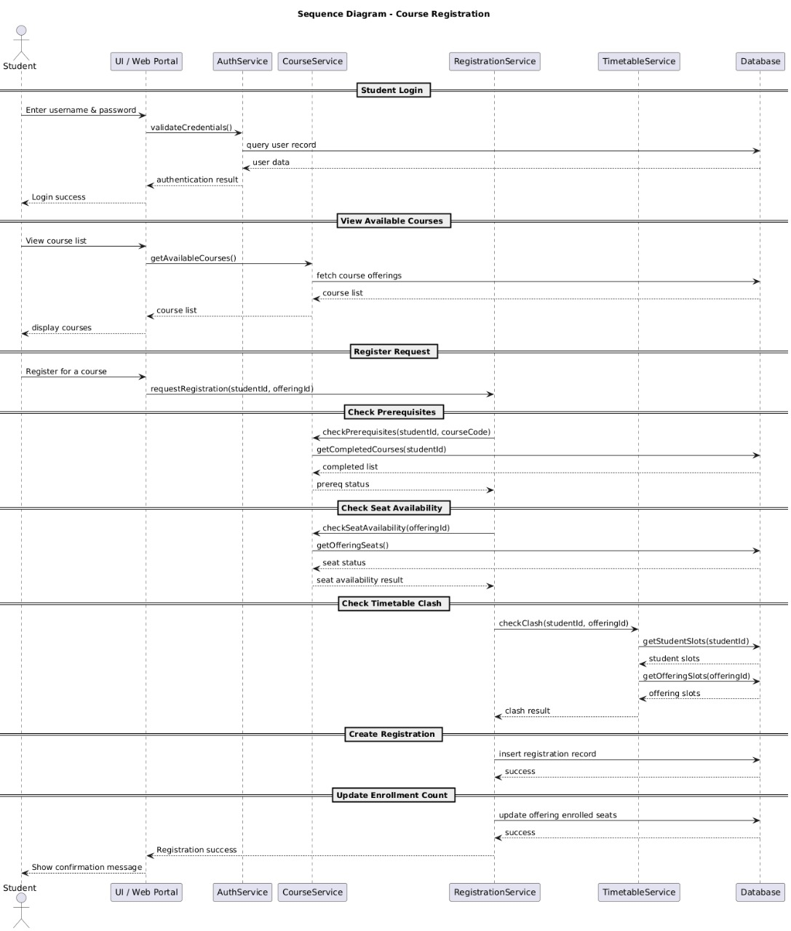
Sequence Diagram
Figure 11: Sequence Diagram for Course Registration and Timetable Scheduler

Reference
- IEEE Std 830-1998. IEEE Recommended Practice for Software Requirements Specifications. Institute of Electrical and Electronics Engineers, 1998.
- Oracle. Java Swing API Documentation. Oracle Corporation.
- MySQL. MySQL 8.0 Developer Reference Manual. Oracle Corporation.
- Quaid-i-Azam University. CS322: Software Construction – Course Manual.

